63BITS Administration Side Part2

The purpose of this document is to define standards and guidelines for building the Product Properties page. It specifies the required form structure, component usage, validation rules, and image upload procedures.
Table of Contents
63BITS Administration Side Part2 1
Permission Setup 2
Building Model / View / Controller Structure 3
Model 4
FormViewModelBase63 Inheritance Rule 4
GetViewModel 6
Validation 8
Validation Process Rules 9
Save 11
DeleteImage 13
Controller 14
View 18
Javascript 24
Launch 25

Permission Setup

Process begins with setting up permissions.
Launch application and navigate to User Management → Permissions. Create following permission hierarchy according to instructions below:
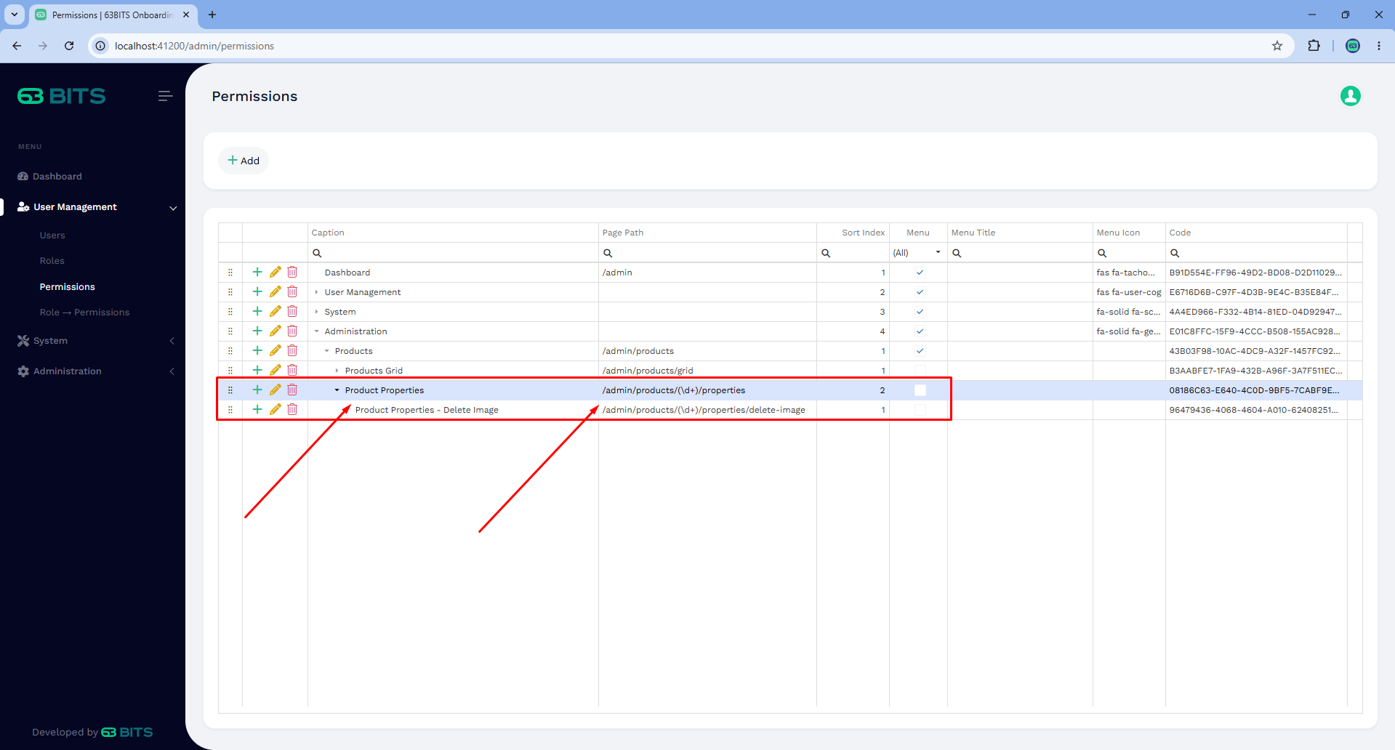

The Page Url field uses a regular expression (\d+) to match numeric values. This allows the permission engine to validate access for any ProductID. For example, the pattern matches URLs like /admin/products/4/properties regardless of the specific product ID.
After registering the permissions, navigate to User Management → Role Permissions and assign the newly created permissions to the Administrator role.

Building Model / View / Controller Structure
The implementation begins by reviewing the expected layout of the Product Properties page and identifying the UI components required to build it.

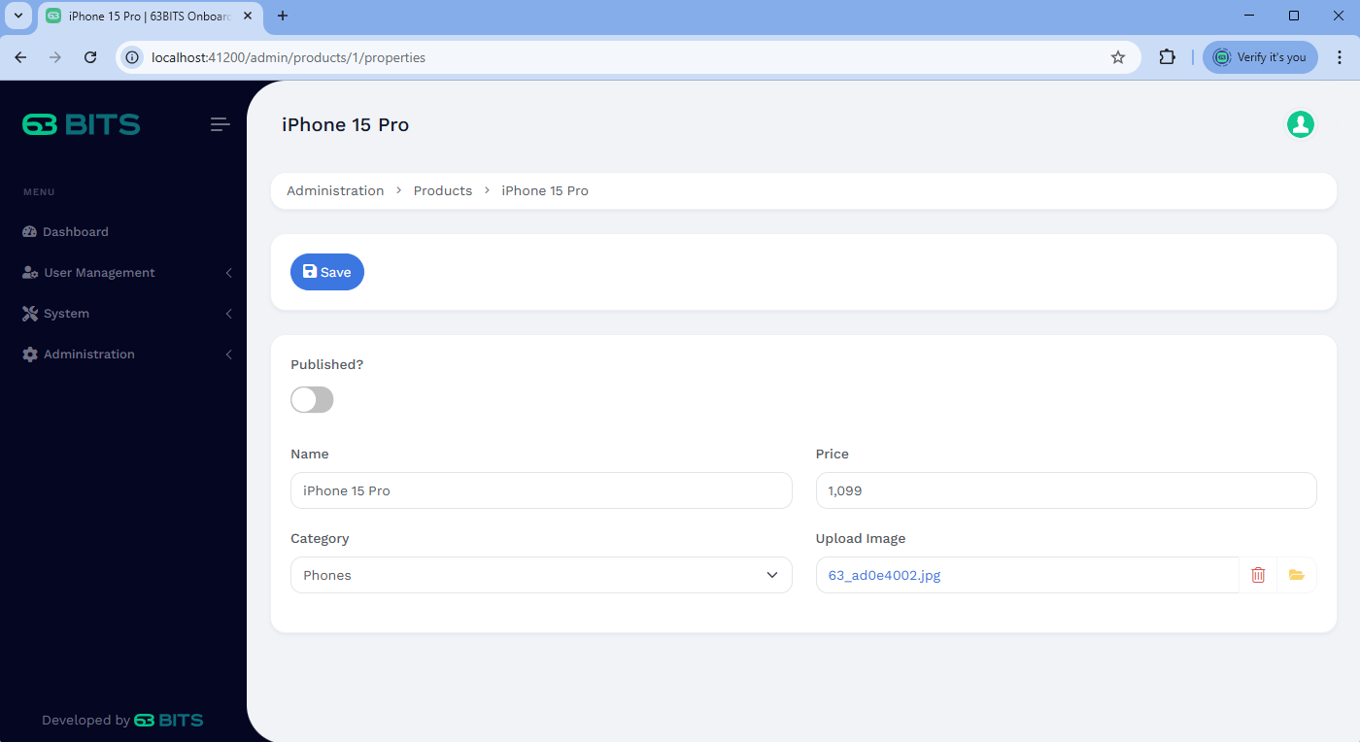

The page should include these elements:
- Save button
- Published checkbox
- Product name text input
- Price input (numbers only)
- Categories dropdown
- Cover image uploader

Model
Navigate to SixtyThreeBits.Web → Models → Admin → Products and create file ProductPropertiesAdminModel.cs

Start building ProductPropertiesAdminModel according to screenshot below.

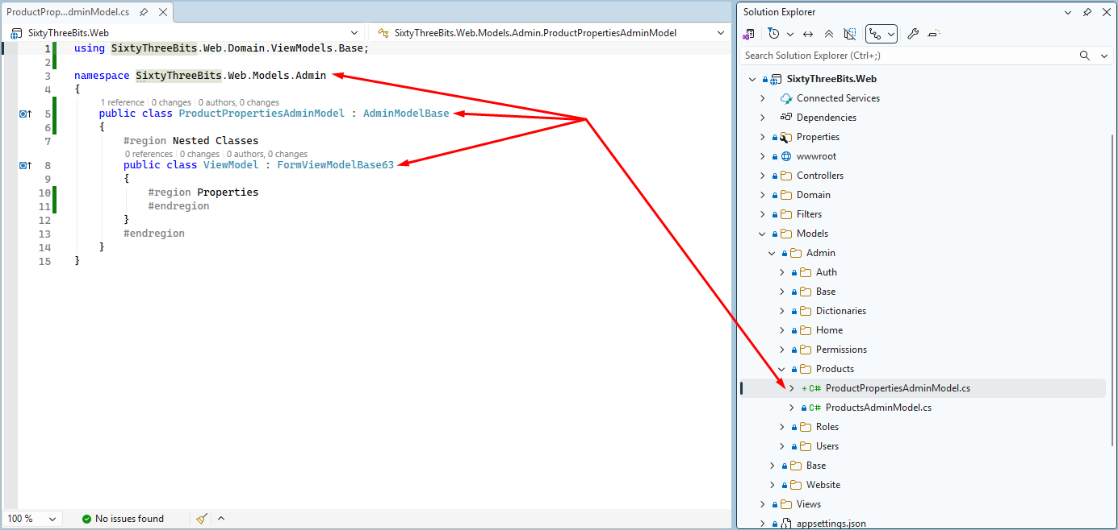

The ViewModel class inherits from FormViewModelBase63, which provides shared form validation helper components used across all forms in the application. FormViewModelBase is located at SixtyThreeBits.Web → Domain → ViewModels → Base → FormViewModelBase.cs

The ViewModel class inherits from FormViewModelBase63, which provides shared form validation helper components used across all forms in the application.

FormViewModelBase63 Inheritance Rule
All ViewModels for form-based pages must inherit from FormViewModelBase63.

Now let’s add following properties to our ViewModel class.

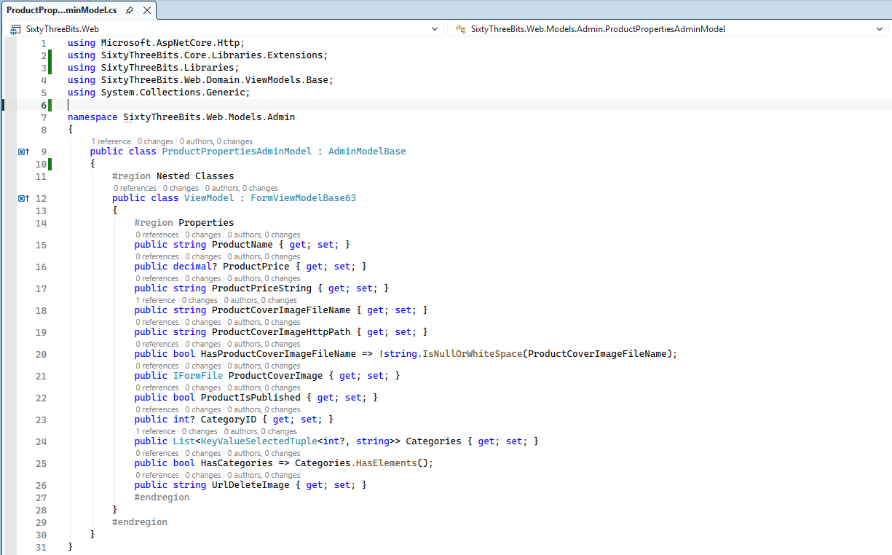

The ViewModel includes two notable properties:
- IFormFile ProductCoverImage – handles uploaded files.
- List<KeyValueSelectedTuple<int?, string>> Categories – stores the list of categories for the dropdown.

Unlike DevExtreme DataGrid, we use KeyValueSelectedTuple instead of KeyValueTuple. The key difference is the bool IsSelected property, which indicates whether an item should be pre-selected in the dropdown when page is initially loaded.

GetViewModel
Add public ProductDTO Product
to the ProductAdminModel, exactly like we did on front-end and implement GetViewModel() method according to screenshot below.
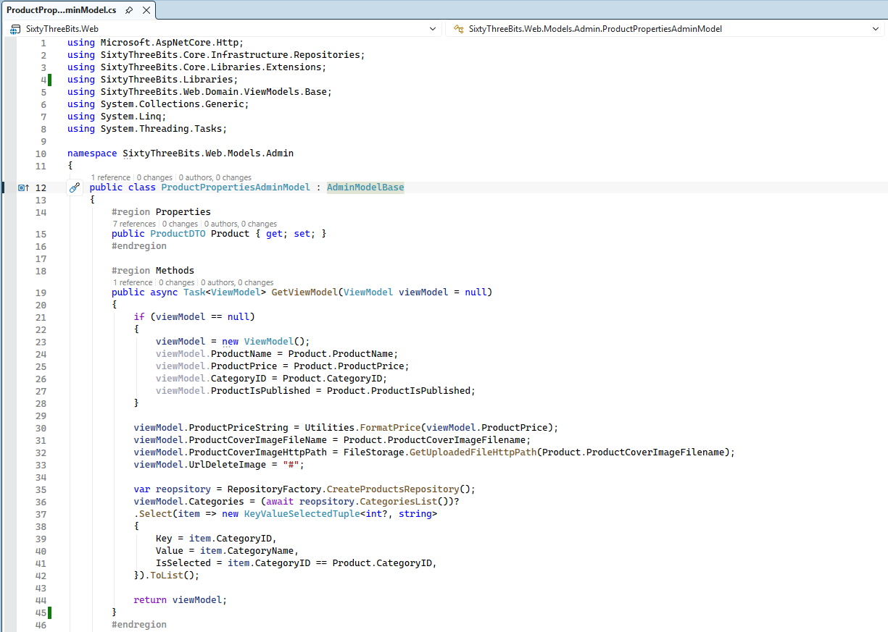

Let’s break down the code:
Why does GetViewModel(ViewModel viewModel = null) receive a viewModel parameter, and why is its default value null?
This method signature and behavior is specifically designed for form-based pages where the form is submitted via a regular HTTP POST (no AJAX). In such scenarios, the ViewModel must support two distinct request flows:

1. HTTP GET – Initial page load
When the page is initially requested, the application must load product data from the database and populate the viewModel. Since no user data has been submitted yet, the viewModel parameter is null and the following block is executed:
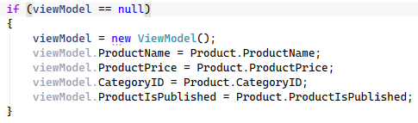
This initializes a new ViewModel instance and assigns values from the database.

2. HTTP POST – Form submission
When the user submits the form, the MVC Model Binding process automatically populates the ViewModel parameter with user-entered values. In this case, viewModel is not null, so the initialization block is skipped. This is critical because:
- We must persist user input when saving to the database.
- If validation fails, we must re-render the view with user-entered values rather than displaying initial database values. This allows the user to see exactly what needs correction.

Shared assignment logic
After the if block, the following code runs in both scenarios (initial page load and form submission):
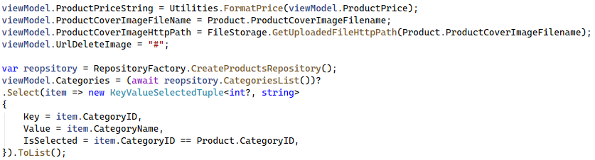
These properties must always come from database, regardless of request type because they depend on system context rather than user input.

Validation
This section is dedicated to the validation logic that will be executed after the form is submitted.
validateSubmitModel() is private method that will validate submitted form and return validation result.
Implement this method according to instructions below:
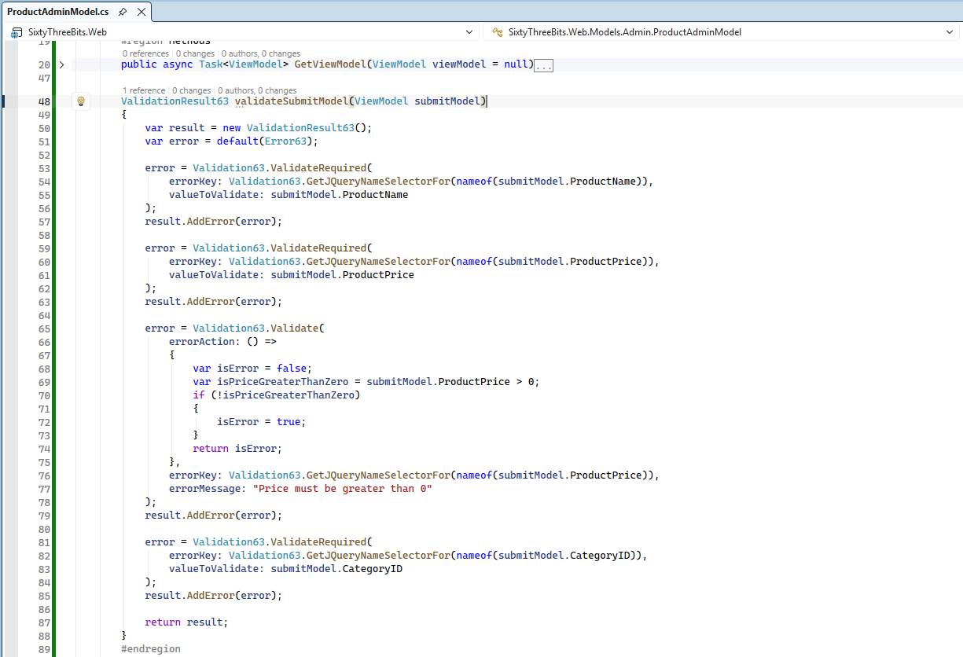

Let’s break down the code:
Form validation is handled using validation classes located in SixtyThreeBits.Core → Libraries → Validation
- ValidationResult63
- Error63
- Validation63

ValidationResult63 is the class responsible for collecting validation errors and exposing properties, such as:
- Errors - IReadOnlyList<Error63> collection.
- ErrorsJson - JSON string.
- ErrorMessage - single concatenated string
- HasErrors - boolean indicating whether any validation errors are present.

Error63 class represents an error via two properties: Key and Value.
- Key – identifies what type of error or where exactly error occurred.
- Value – identifies error message.
Validation63 class provides the most commonly used validation methods, such as:
- Required field validation
- Email validation
- Password validation
- Custom validation – method accepting delegate for performing custom validation logic.
Each validation method returns:
- Error63 instance when validation fails.
- null when validation succeeds.
An instance of the ValidationResult63 class collects Error63 objects using AddError() method. This method is designed to gracefully ignore null values, ensuring that only actual validation errors are added to the collection.

Validation Process Rules
All validation errors must be represented by instances of the Error63 class.
All validation operations must be executed through the Validation63 class, either by using its predefined validation methods or by providing a delegate to its custom validation method.
All validation results must be gathered and returned via an instance of ValidationResult63.

This unified approach ensures consistency, maintains the cooperative workflow between the three classes, and provides complete independence from the client-side implementation or error rendering mechanisms.
Summary:
- Validation63 performs validation and returns an Error63 when validation fails and null when succeeds.
- ValidationResult63 collects and manages errors, exposing them in multiple formats.
- Error63 represents a single validation error instance.

Look back at the code and pay attention to Validation63.GetJQueryNameSelectorFor. This method call is designed to populate errorKey.
Since our client-side implementation is based on jQuery, the Validation63 class includes helper methods
- GetJQueryClassSelectorFor(string key)
- GetJQueryIDSelectorFor(string key)
- GetJQueryNameSelectorFor(string key)

for generating the appropriate error keys, that will be used on client-side, by jQuery, to display and highlight as red error locations. These utilities significantly simplify the client-side rendering process.
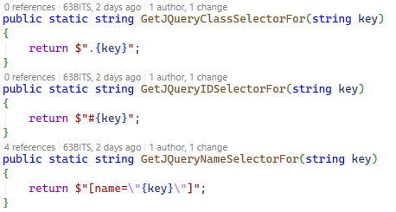

For additional understanding of how jQuery selectors work, refer to the documentation below:
https://api.jquery.com/attribute-equals-selector/

Save
The next step for the model is to implement the Save() method, which will store data submitted from the form in the database.

Implement this method according to instructions below:
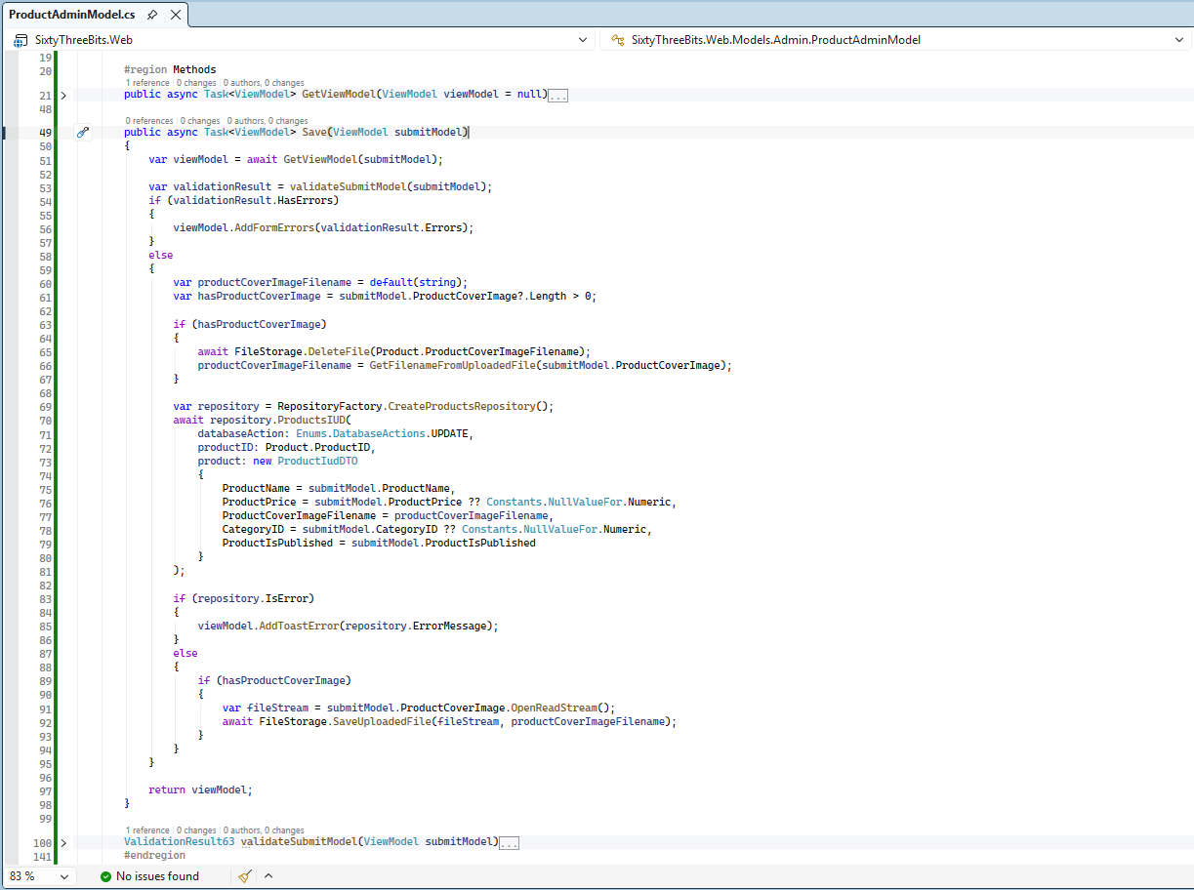

Let’s break down the code:
var viewModel = await GetViewModel(submitModel)
This is the point where we utilize the GetViewModel(ViewModel viewModel = null) method signature designed specifically for form-based pages. In this scenario, form submits data and viewModel is already created and populated through the MVC Model Binding process. The method is called with submitModel, ensuring that user-entered values are preserved rather than overwritten by database data.

var validationResult = validateSubmitModel(submitModel)
Next, we call our previously designed validateSubmitModel method to perform validation on the submitted form data. When errors are detected we add them to the viewModel to deliver them on the view for rendering.
viewModel.AddFormErrors() – method is inherited from FormViewModelBase63.

The next section of the code is responsible for detecting whether an image was uploaded. When an uploaded image is present, the process begins by removing the existing image and then assigning the filename of the newly uploaded image. After the old image is removed, the data is saved to the database, and once the save operation is completed successfully, the new image is saved to the file system.
FileStorage model property, inherited from ModelBase manages uploaded files across the platform.
Maintaining the following sequence is critical for ensuring data integrity between the database and the file system:
- Delete the old image.
- Save the form data to the database.
- Save the newly uploaded image to disk.
This ordered approach guarantees consistency and prevents mismatches between file storage and database state.

viewModel.AddToastError(repository.ErrorMessage)
If an error is returned by the repository, it is treated as a non-validation error. In this case, the error message is added to the viewModel as a toast notification.
AddToastError – method is inherited from FormViewModelBase63.

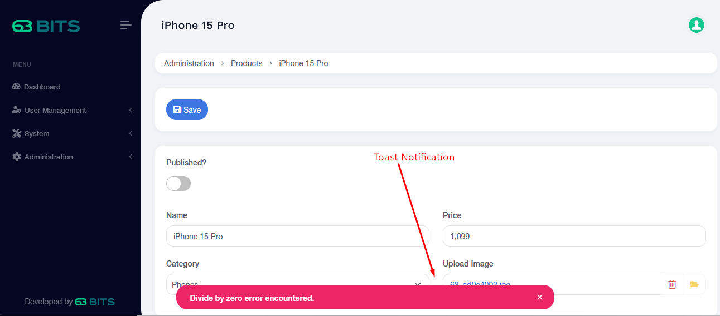

DeleteImage
DeleteImage() is the final method for our model. This method is specifically dedicated to removing product cover image only.
Implement this method according to instructions below:
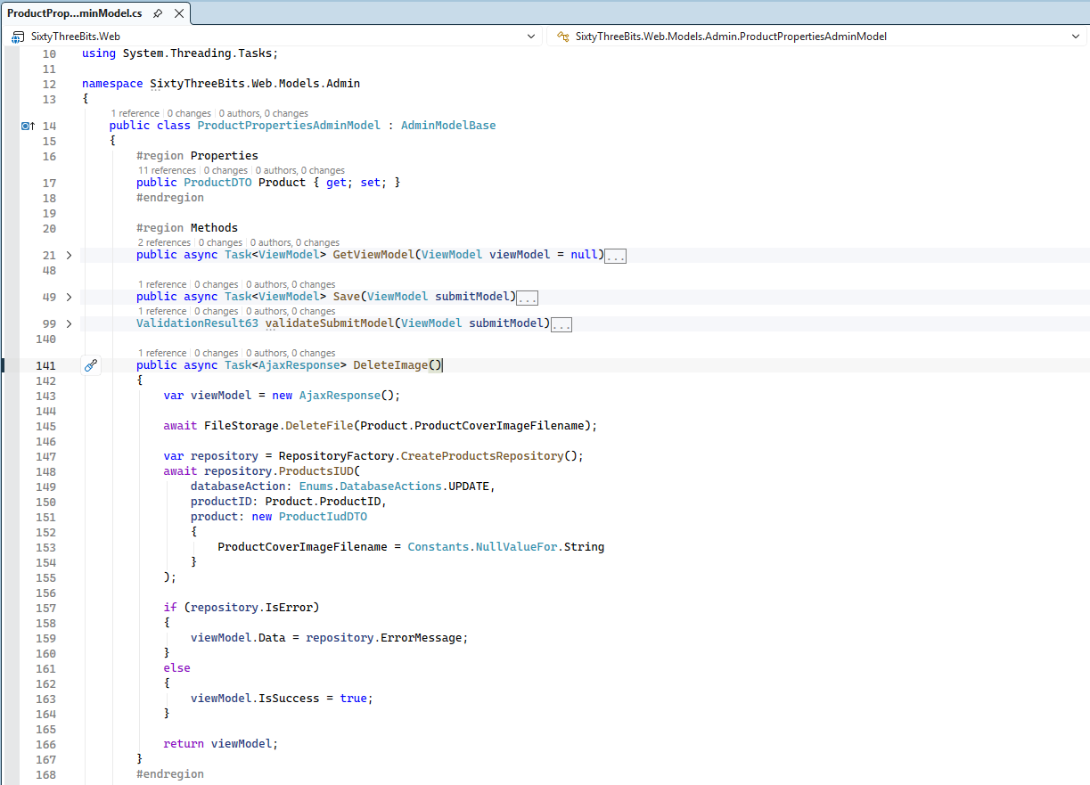

System will use it to remove product cover image via AJAX call.

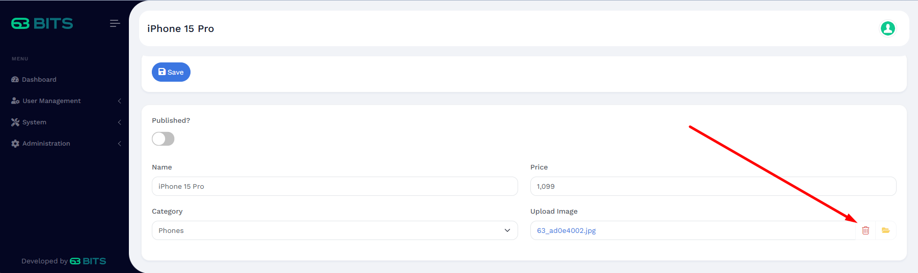

Controller
Navigate to the SixtyThreeBits.Web → Controllers → Admin → Products and create ProductPropertiesAdminController.cs file.

Implement _viewName and OnActionExecutionAsync similar to WebsiteController. Follow the screenshot instructions and note the arrows indicating differences from the website implementation.

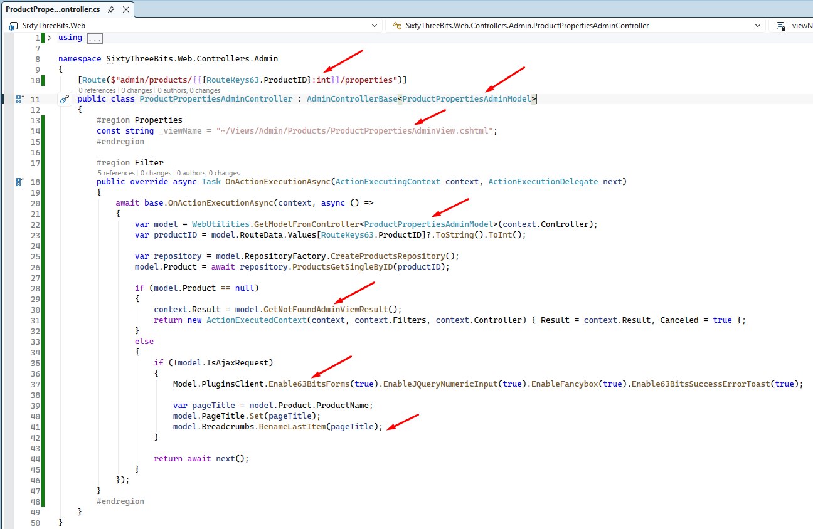

Next implement action methods according to instructions below:
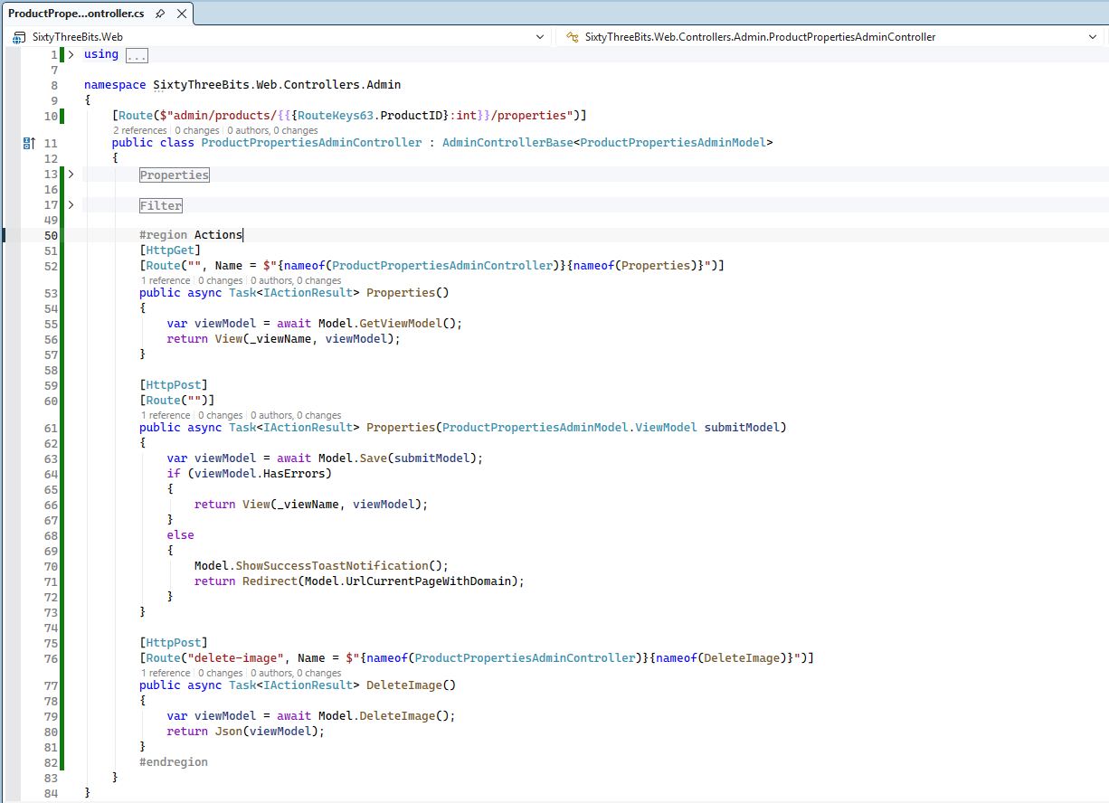

Once all controller actions are created, go back to ProductPropertiesAdminModel and set proper url for deleting product image.
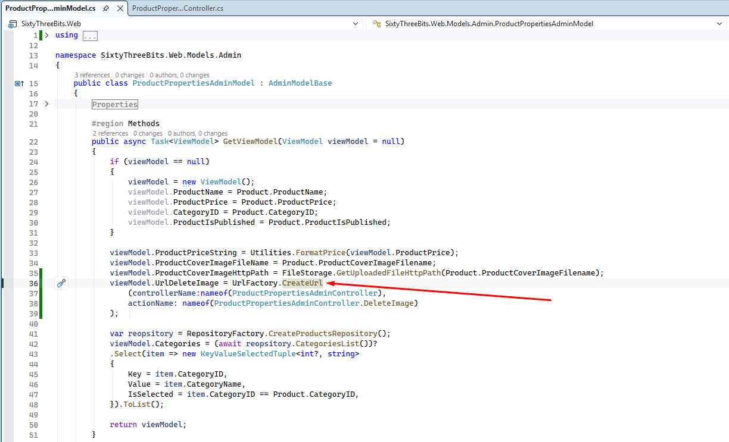

Also go back to ProductsAdminModel and and set proper url for product properties page.
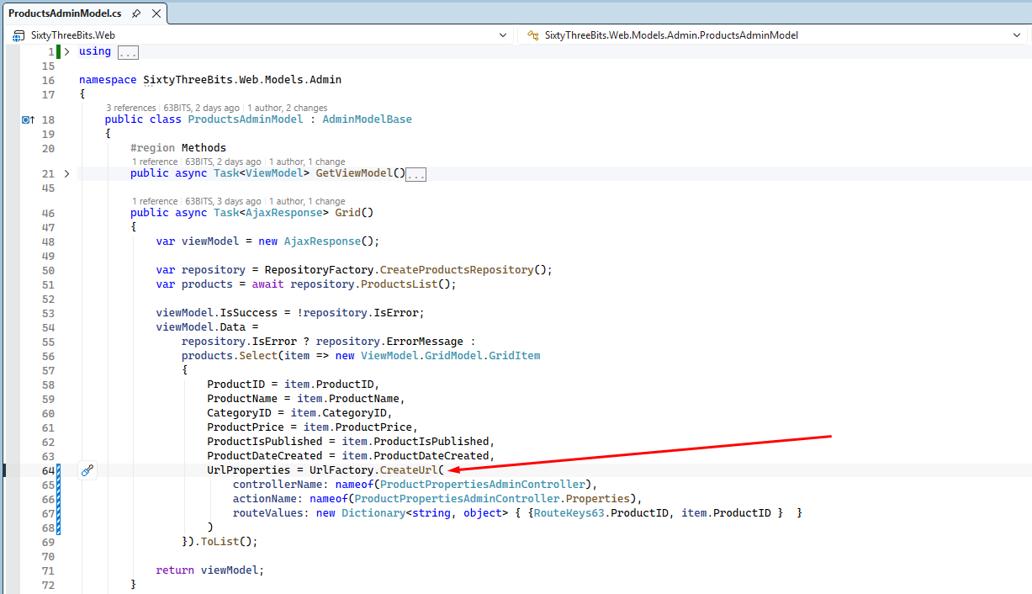

View
Navigate to the SixtyThreeBits.Web → Views → Admin → Products and create ProductPropertiesAdminView.cshtml file.

This view will be more extensive than previous examples, so we will construct it incrementally by adding small, manageable blocks of HTML.

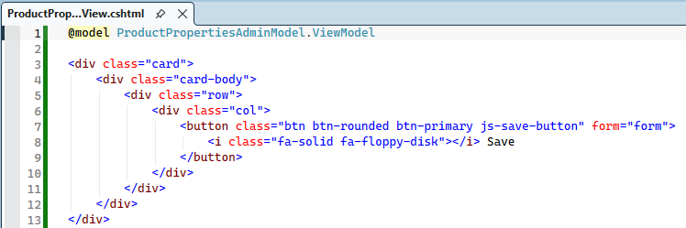

The code above associates the ViewModel with the view and renders a Bootstrap card containing the Save button. The button includes the attribute form="form", which indicates that clicking the button must submit the form with id="form".

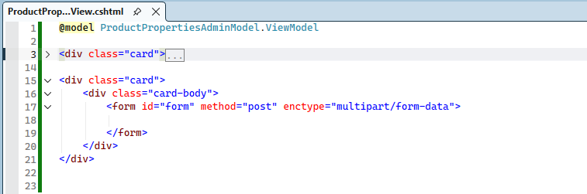

The next section creates another Bootstrap card that contains the form used to edit product properties:
<form id="form" method="post" enctype="multipart/form-data">
- id="form" – Links the form to the Save button, enabling the form submission when the button is clicked.
- method="post" – Specifies that the form data should be submitted using an HTTP POST request.
- enctype="multipart/form-data" – Required when the form includes file uploads, such as images.

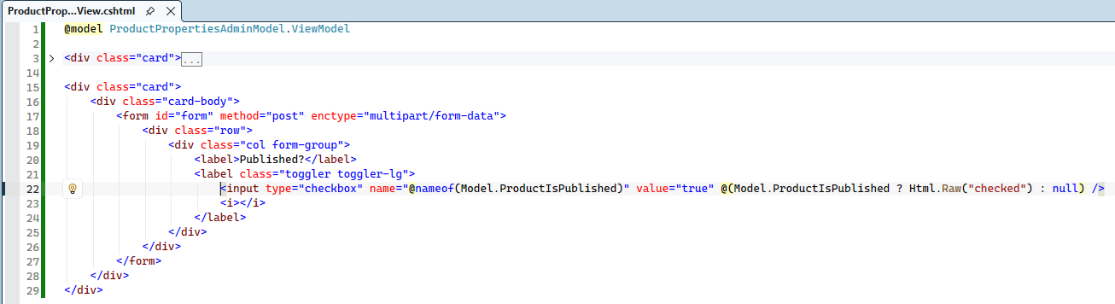

This block creates a row containing a checkbox element that represents whether the product is published. Below is a breakdown of the key attributes used in the checkbox:
- name="@nameof(Model.ProductIsPublished)" – The name attribute value must exactly match the ProductIsPublished property name in the ViewModel class. This enables the MVC model binding engine to correctly map the submitted value to the ViewModel properties.
The nameof operator prevents hard-coding, ensuring that if the property name is ever changed, the attribute value updates automatically.
- value="true" – This value must always be explicitly provided for correct model binding. All checkbox inputs should follow this requirement.
- (Model.ProductIsPublished ? Html.Raw("checked") : null) – This logic determines whether the checkbox should be pre-selected. If the product is published, the checked attribute is rendered; otherwise, it is omitted.

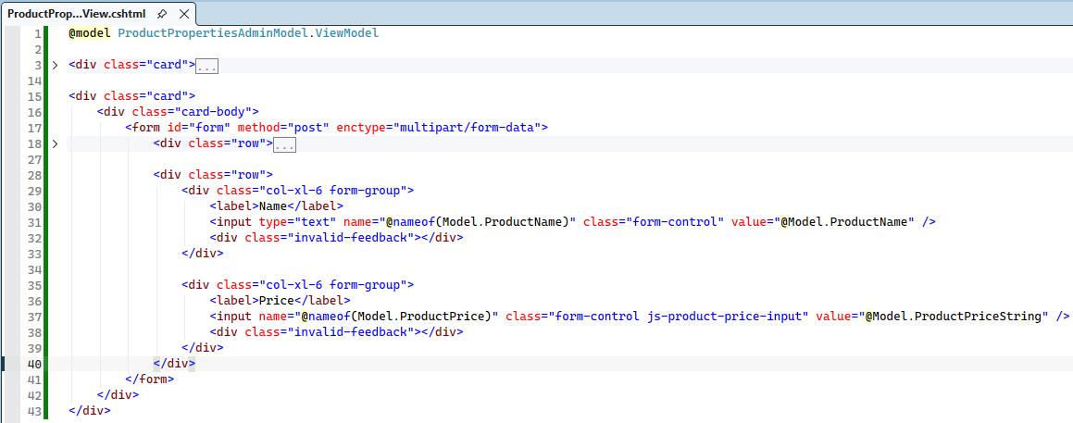

These lines create a row containing the ProductName and ProductPrice input elements. Similar to the checkbox example, the name attribute enables model binding.
The value attribute displays data from the ViewModel.
Let’s break down attributes for the ProductPrice element:
- name="@nameof(Model.ProductPrice)" - This attribute maps directly to the ProductPrice property in the ViewModel, enabling the MVC model binding process to correctly receive the submitted value.
- value="@Model.ProductPriceString" - This attribute is bound to ProductPriceString rather than ProductPrice. Since ProductPrice is a decimal? and may contain four decimal places (e.g., 85.9900), ProductPriceString is used to display a user-friendly formatted value such as 85.99.
- class="... js-product-price-input" - This CSS class is solely designed to be used by the JavaScript logic. It allows jQuery to:
  - Locate this input using the .js-product-price-input class.
  - Convert the input into a numeric-only field using the jquery.numericInput library, which is included via the .EnableJQueryNumericInput(true) call in the controller.
The result is following: We display a formatted value (ProductPriceString) to the user, but when the form is submitted, the correctly formatted input is mapped back to the ProductPrice property, ensuring proper data persistence.
<div class="invalid-feedback"></div> - serves as the container where validation error messages will be displayed when validation fails.

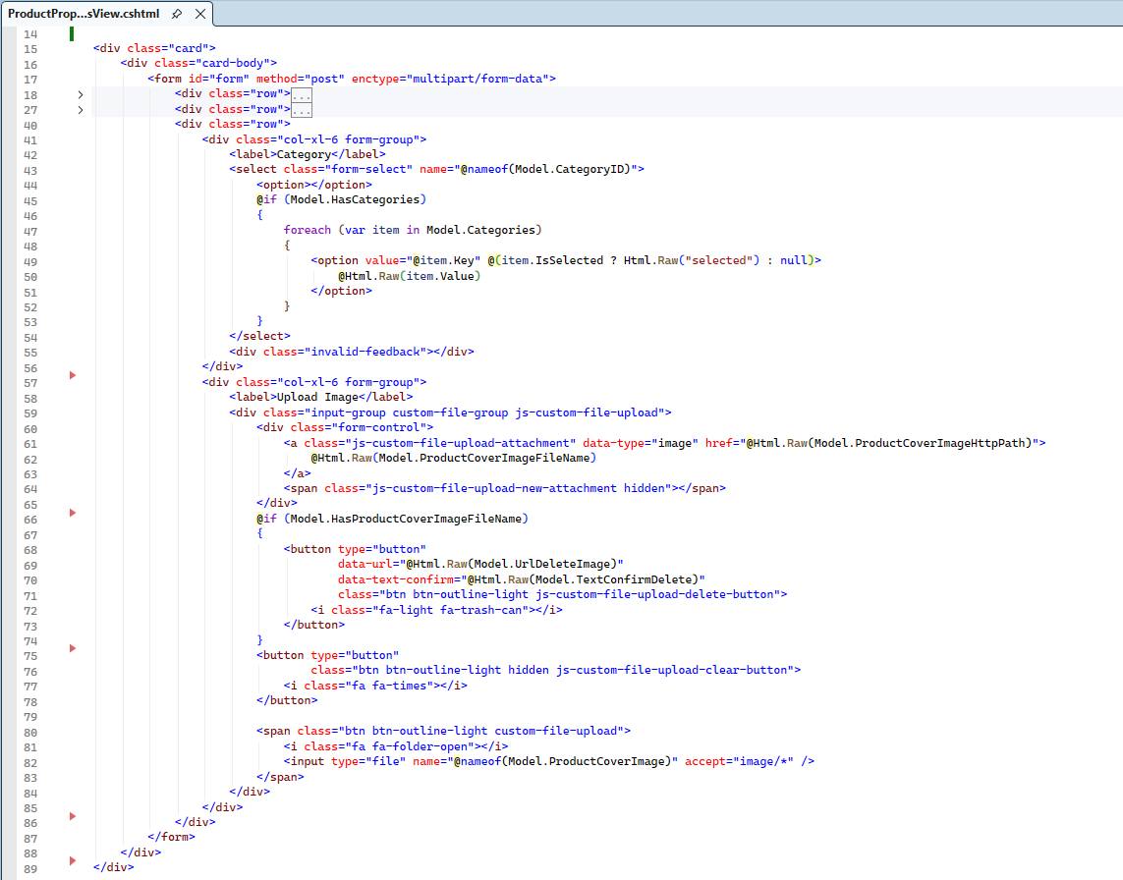

These lines create a row that contains the Categories drop-down list and the Product Cover Image upload component.

Categories Drop-Down
The <select name="@nameof(Model.CategoryID)" > element generates the category selection list:
name="@nameof(Model.CategoryID)" - Maps the selected value back to the CategoryID property in the ViewModel, enabling proper model binding.

@if (Model.HasCategories)
Before rendering the list items, the code checks whether the categories collection contains any elements. If so, it iterates through them and creates options.

Product Cover Image
The <div class="input-group custom-file-group js-custom-file-upload"> represents the standard upload component structure used across the 63BITS system.
The <a class="js-custom-file-upload-attachment" tag includes:
- data-type="image"
- href="@Html.Raw(Model.ProductCoverImageHttpPath)"
These attributes enable full-screen image preview functionality handled by the client-side script.
@if (Model.HasProductCoverImageFileName)
<button ... class="btn btn-outline-light js-custom-file-upload-delete-button">
Delete Image Button element is shown only when product cover image has already been uploaded.
data-url="@Html.Raw(Model.UrlDeleteImage)" attribute instructs the JavaScript component which endpoint to call via AJAX to delete the image.

<input type="file" – File Uplaoder Component uses following attributes:
- name="@nameof(Model.ProductCoverImage)" - maps the file upload to the
IFormFile ProductCoverImage property.
- accept="image/*" – filters the file selection dialog to display only image files.

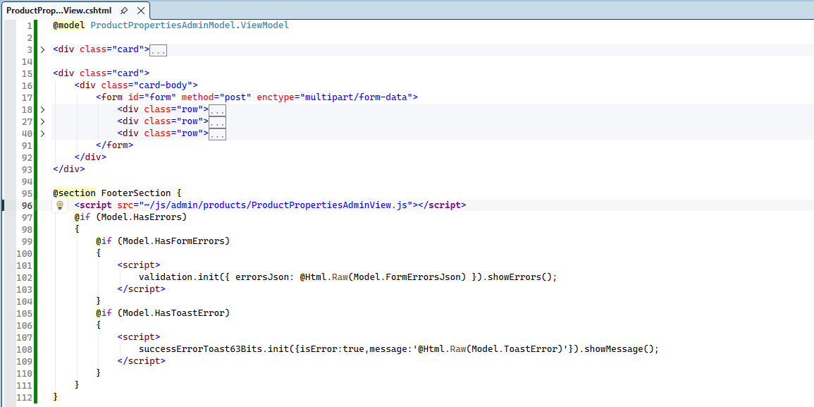

@section FooterSection – is the section where page-specific JavaScript code is included. This section loads the JavaScript file associated with the view and checks whether any errors were reported by the Model.
Properties:
- Model.HasFormErrors
- Model.FormErrorsJson
- Model.HasToastError
- Model.ToastError
Are available through FormViewModelBase63 inheritance.
validation JavaScript object becomes available on the page because /plugins/ 63bits-bsforms/63bits-bsforms.js and 63bits-bsforms.css files are included on page via .Enable63BitsForms(true) call.
<script>
validation.init({ errorsJson: @Html.Raw(Model.FormErrorsJson) }).showErrors();
</script>
Script above is responsible for displaying error messages collected on model level.
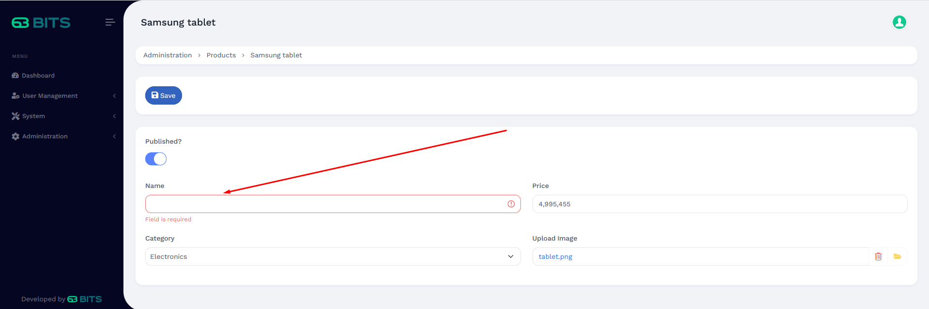

<script>
successErrorToast63Bits.init({isError:true,message:'@Html.Raw(Model.ToastError)'}).showMessage();
</script>
Script above is responsible for displaying toast message, generic error when repository level error occurs.

Javascript

Navigate to the SixtyThreeBits.Web → wwwroot → js → admin → products and create ProductPropertiesAdminView.js file.
Implement javascript according to screenshow below.
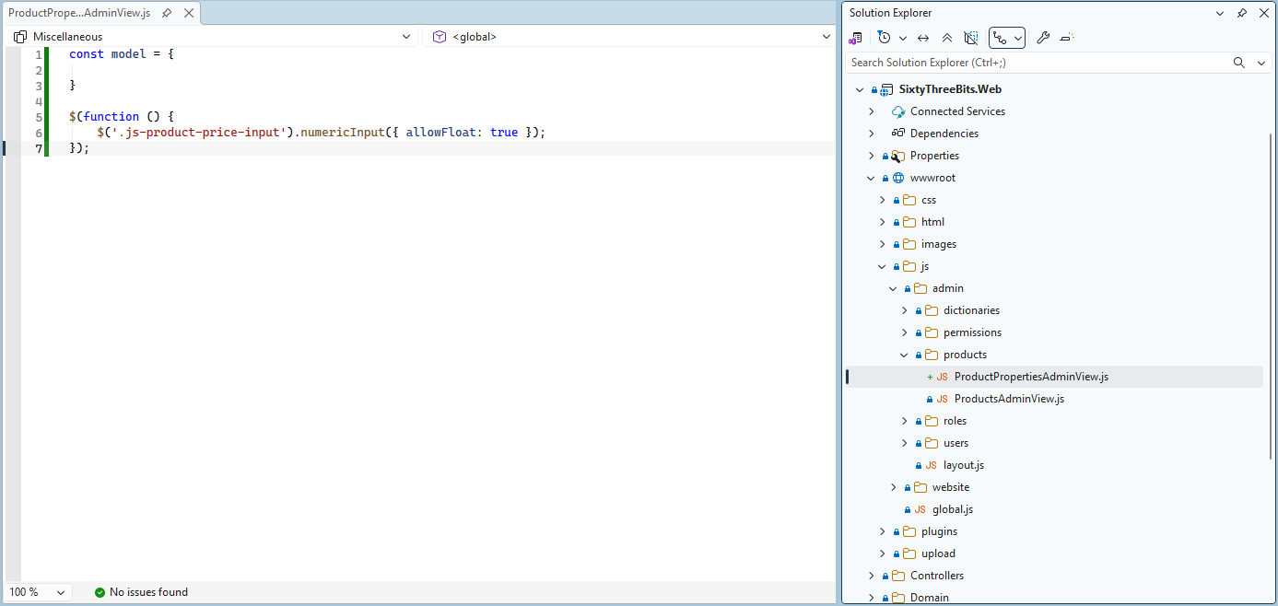

The JavaScript portion here is minimal. We define a model object, but no properties or functions are added at this time; they are not needed, but structure is maintained, solely for consistency across the project.
Inside the $(function () { ... } block, we register the numericInput function for the product price field, ensuring that only numeric characters can be entered. The numericInput method is provided by the JavaScript library that was included via the controller using .EnableJQueryNumericInput(true)
This setup guarantees correct input formatting for product price values.

Launch
Launch your application, navigate to products page and make sure that link to product properites page works.
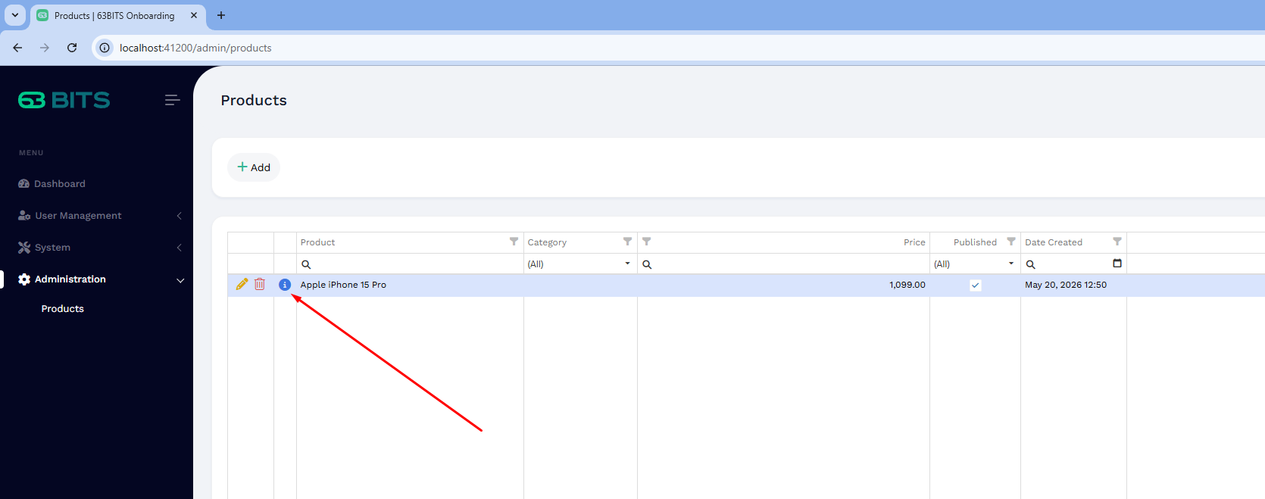
In case you see 404 page, Double check Role – Permissions. Login – Logout and try to click product properties link again.

Once you are on properties page,
- Test empty field validation.
- Test price numeric field, make sure no characters are allowed.
- Test image upload/delete, Check wwwroot\upload directory, make sure that file is uploaded and delete from hard drive.
